Before you connect,

1. Before you connect, ask your students to download (click on the link below) the free “Zoom Client for Meetings App”. This is preferred but not absolutely necessary.

[https://zoom.us/download](https://nam04.safelinks.protection.outlook.com/?url=https%3A%2F%2Fzoom.us%2Fdownload&data=02%7C01%7C%7C9326d3aeabaf4d018c9e08d7c92fe43f%7C5de2c3fcbc60408c9cf8abe2ebade9aa%7C1%7C0%7C637199079861032641&sdata=%2B2OyDZeLO0QVvS0C06z%2FHbgPGHDQWlZ2v9rXZEv2OrI%3D&reserved=0) and download "Zoom Client for Meetings"

1. If they are using a mobile device (iPad, iPhone, Android, etc.) they will need to download the “Zoom Cloud Meetings” App from the App Store.

 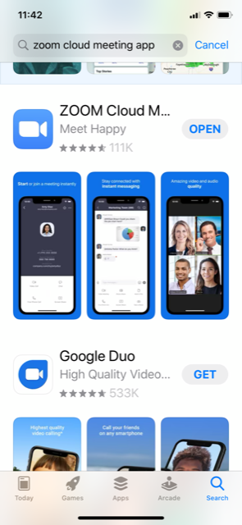

1. Later, when you invite them to join a videoconference, they will see this in the email invitation. All they have to do is click on “Allow”.

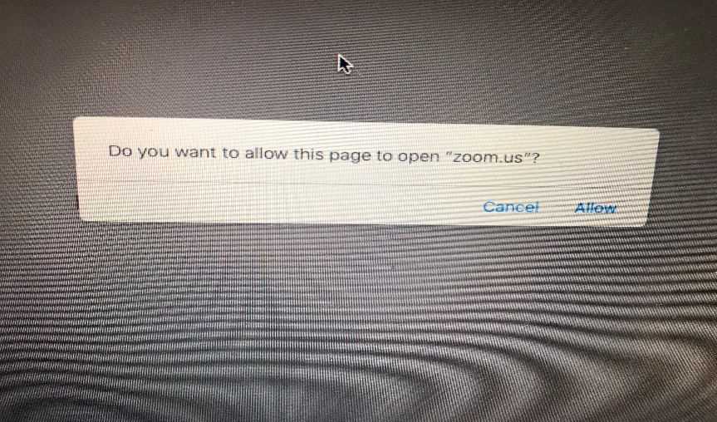

**It is also important that your students change their audio settings**. You can help them change their settings at the start of a videoconference. Your students would be seeing the screen below during a lesson. Talk them through the process of changing the settings as described below. These are the same changes you had made earlier. Now you’re just getting to them through a different path.

1. Click on the up arrow next to the microphone icon, bottom left hand corner of the screen.

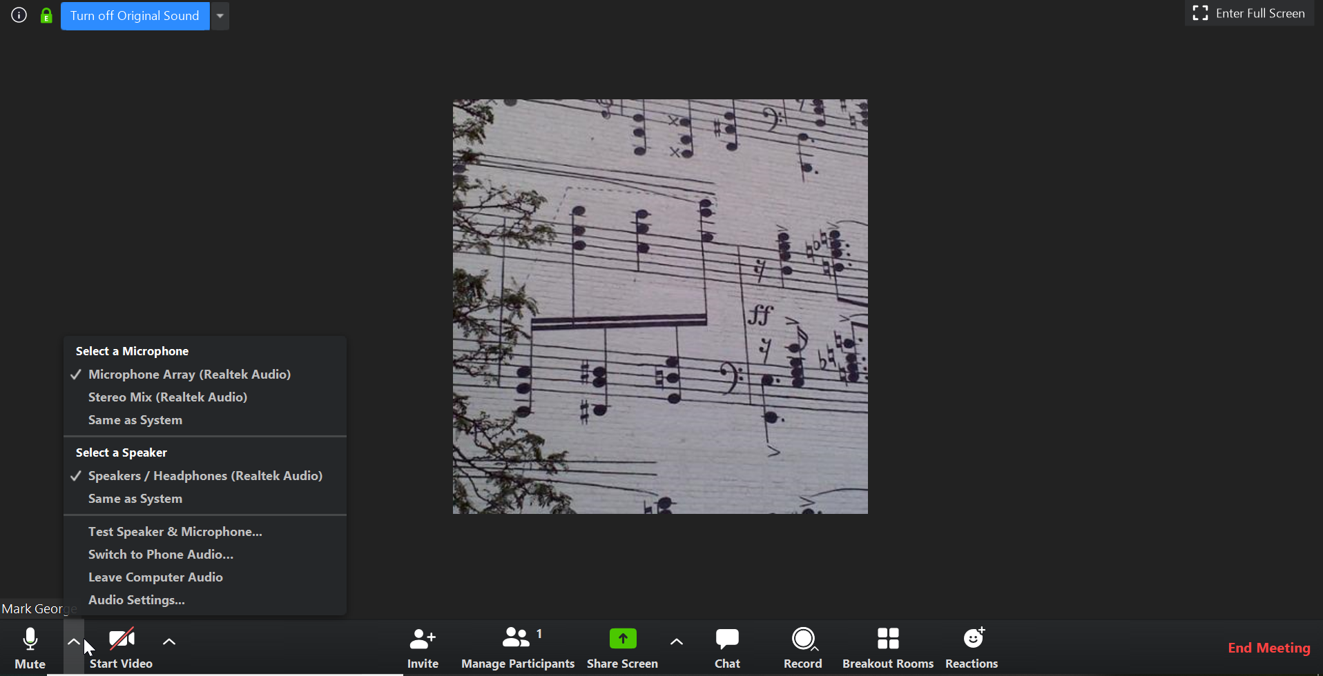

1. Click on “Audio Settings…”

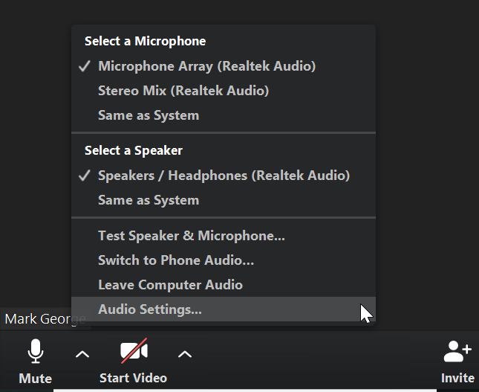

1. Click and ‘un-check’ the box that says, “Automatically adjust volume”. Move the slider (immediately above the check box) to around 75% volume as shown below.

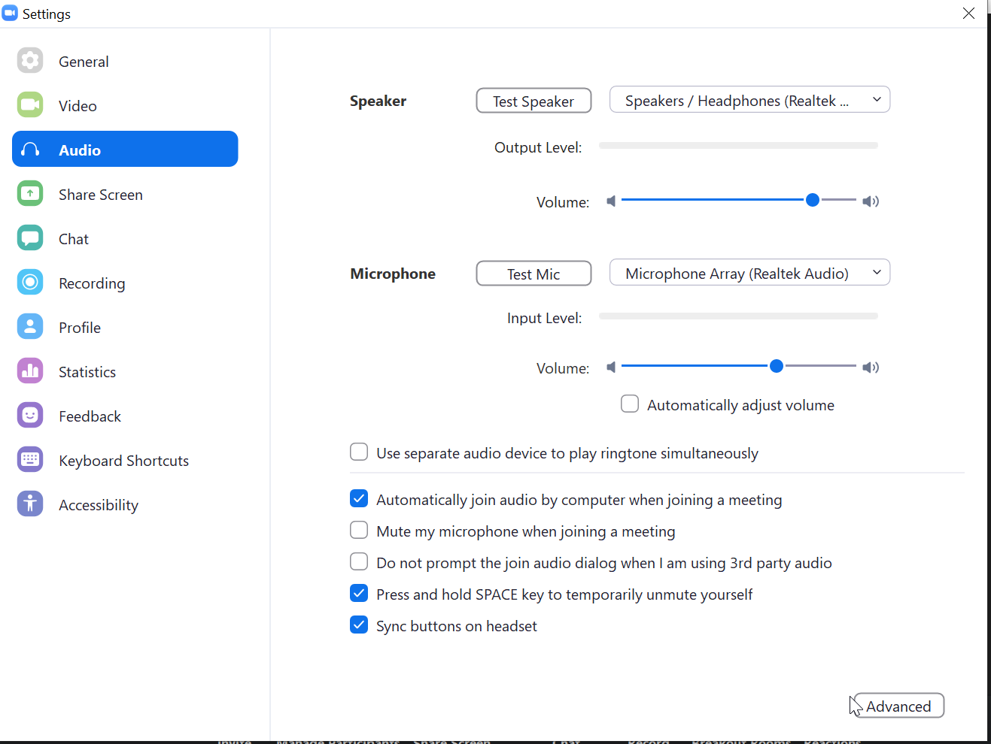

1. Click on “Advanced” in the bottom right hand corner and see the screen below. Click on the box that says “Show in-meeting option to ‘Enable Original Sound’ from microphone”. Then use the use the down arrow next to: “Suppress Persistent Background Noise” and set it to ‘Disable’. Then, just below that, use the down arrow next to: “Suppress Intermittent Background Noise” to ‘Disable’. The entire screen should look like this:

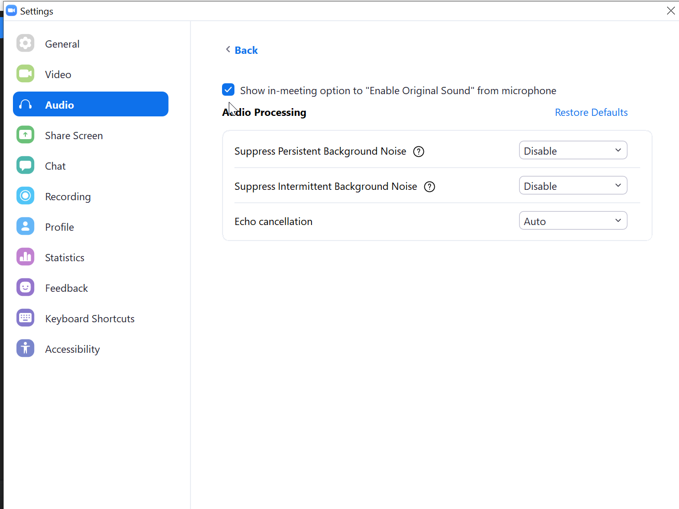

1. Click the “X“ in the upper right hand corner to return to the videoconference screen. Be sure that the words in the upper left hand corner of the screen say: “Turn Off Original Sound”. You may have to revisit this point in every lesson.

