- Open your Zoom App. Click on “Settings”, the little icon in the upper right hand corner that looks like a gear. The “Settings” page should appear
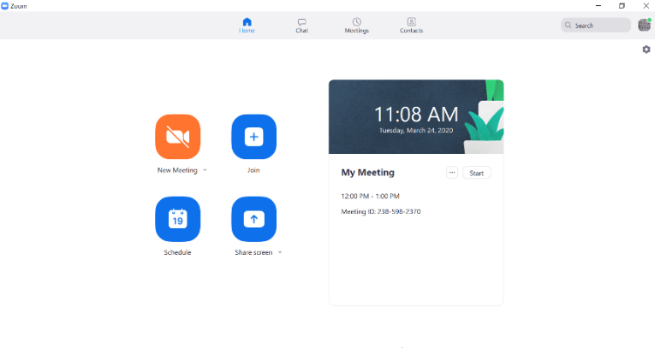
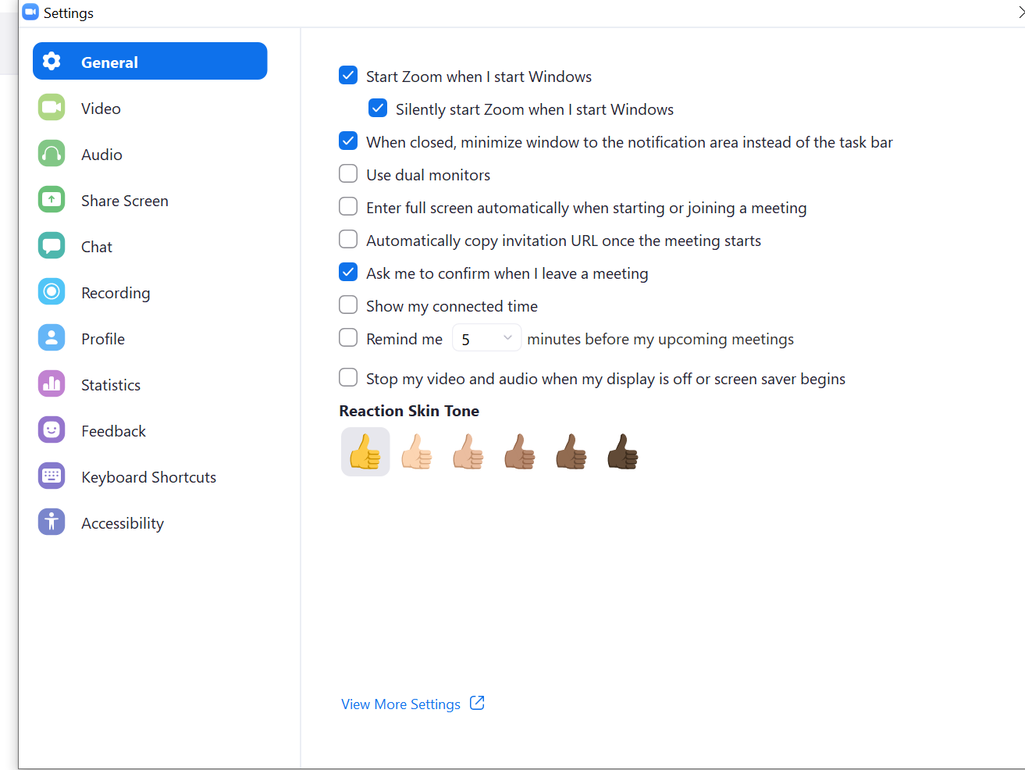

- Click on “Audio” from the menu on the left side of the screen

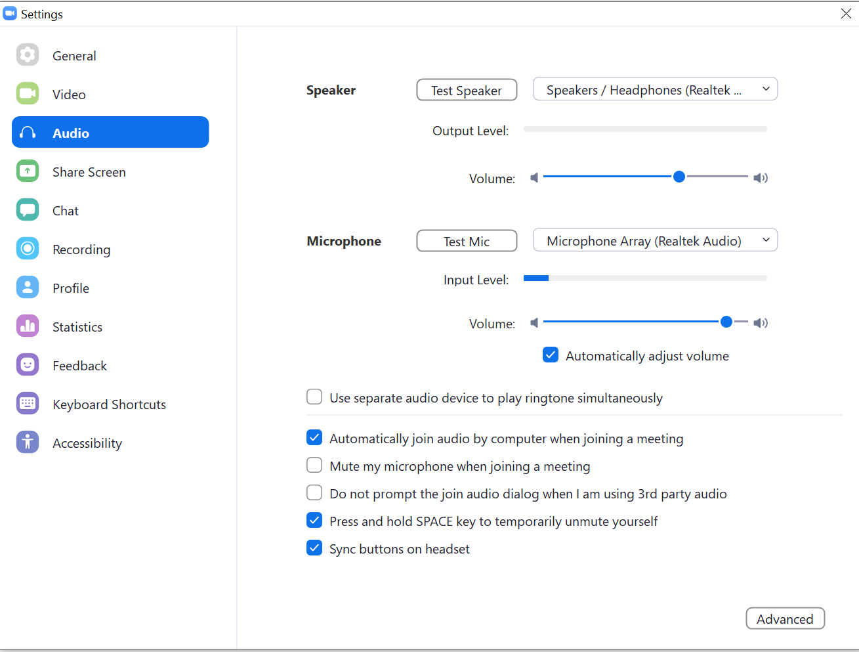

- Click the check box in the middle of the page called “Automatically adjust volume” so that it is NOT checked. I have found that if you slide the volume to the right (about 75% or more of the way), the sound is better.

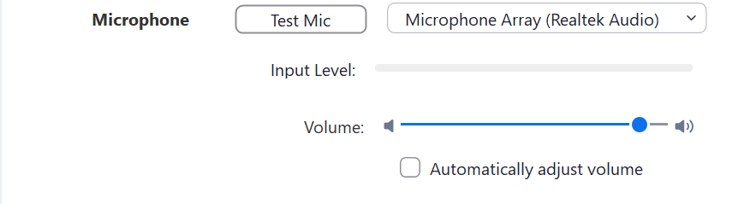

- On the same page, click on “Advanced” in the lower right hand corner and you should see the page below. Do (3) three things. Most importantly, check the box near the top of the screen marked “Show in meeting option to ‘Enable Original Sound’ so that the box turns blue.

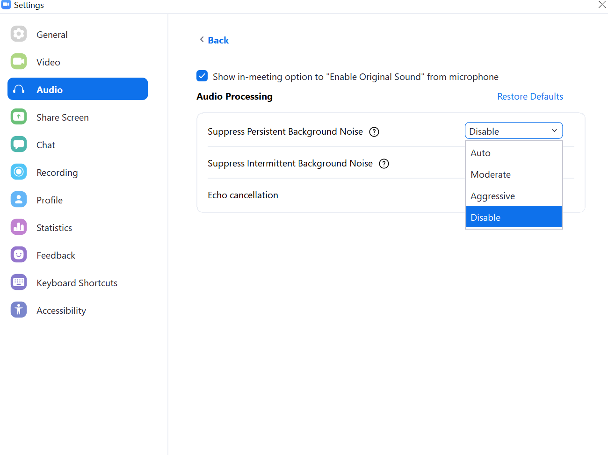

- Then use the use the down arrow next to: “Suppress Persistent Background Noise” and set it to ‘Disable’. Then, just below that, use the down arrow next to: “Suppress Intermittent Background Noise” to ‘Disable’. The entire screen should look like this:
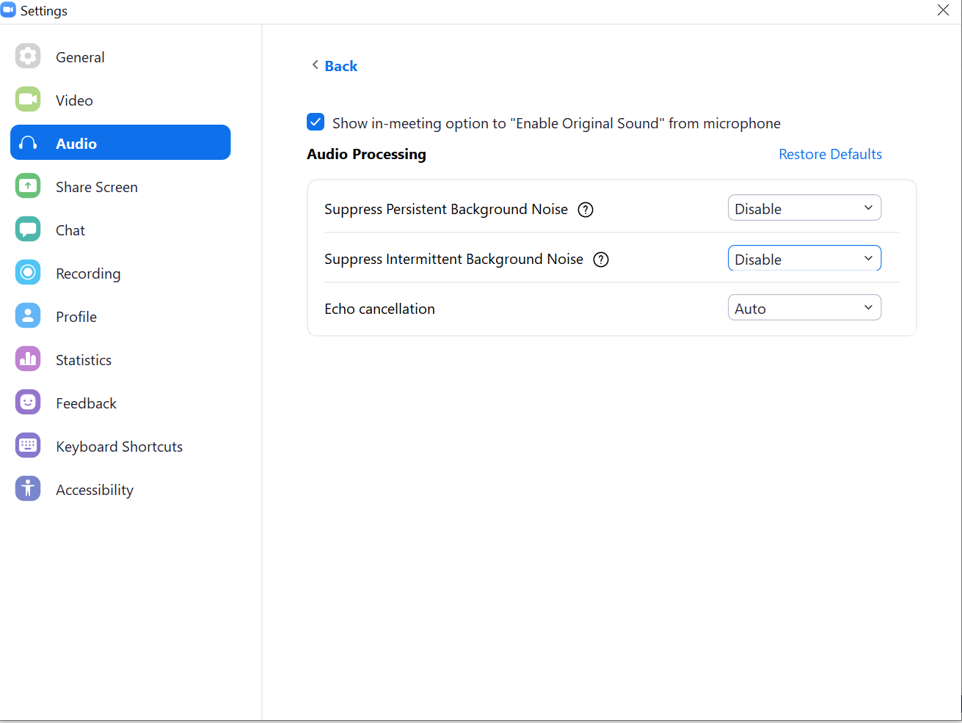

- Click the “X” in the top right hand corner of the screen.
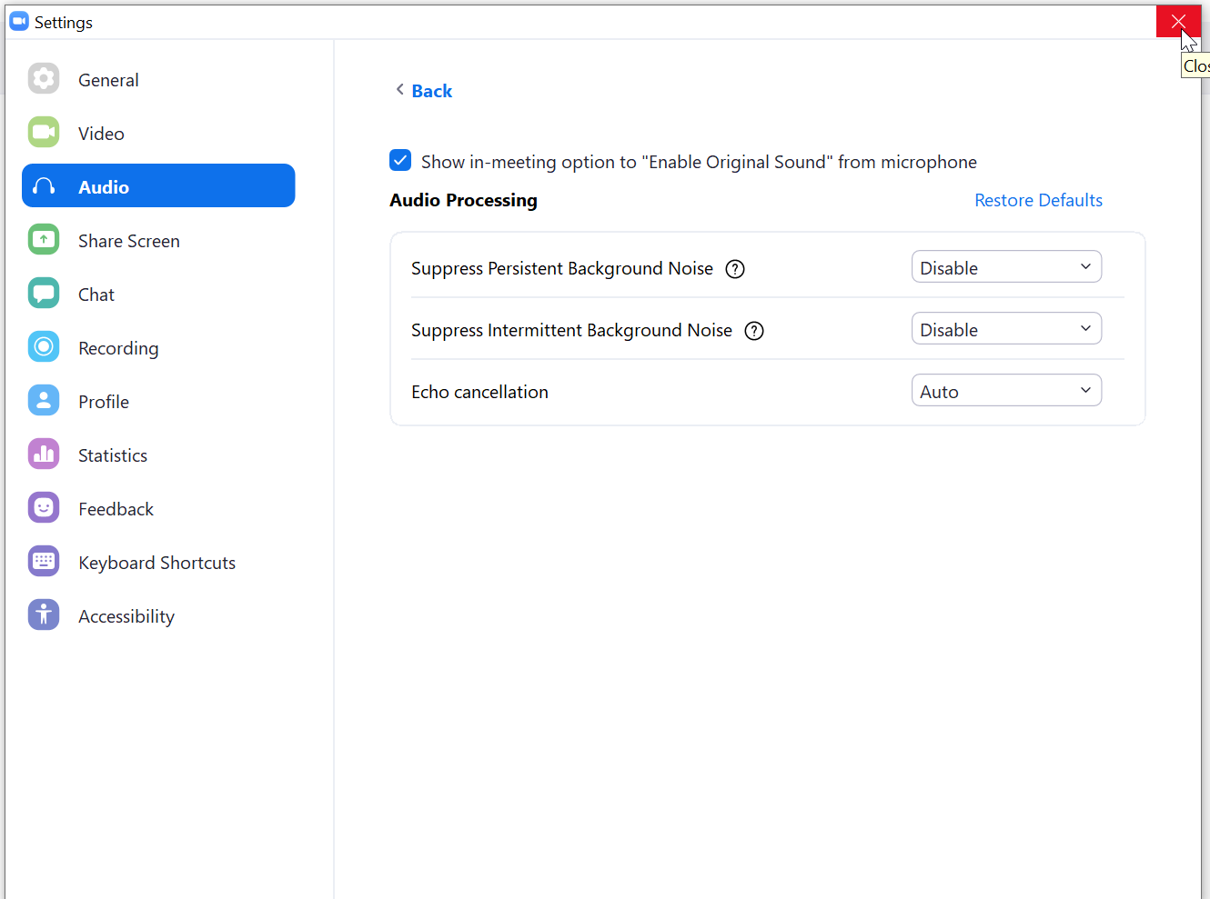

This should return you to your Zoom home screen. Invite your students to videoconference with you as you normally would.

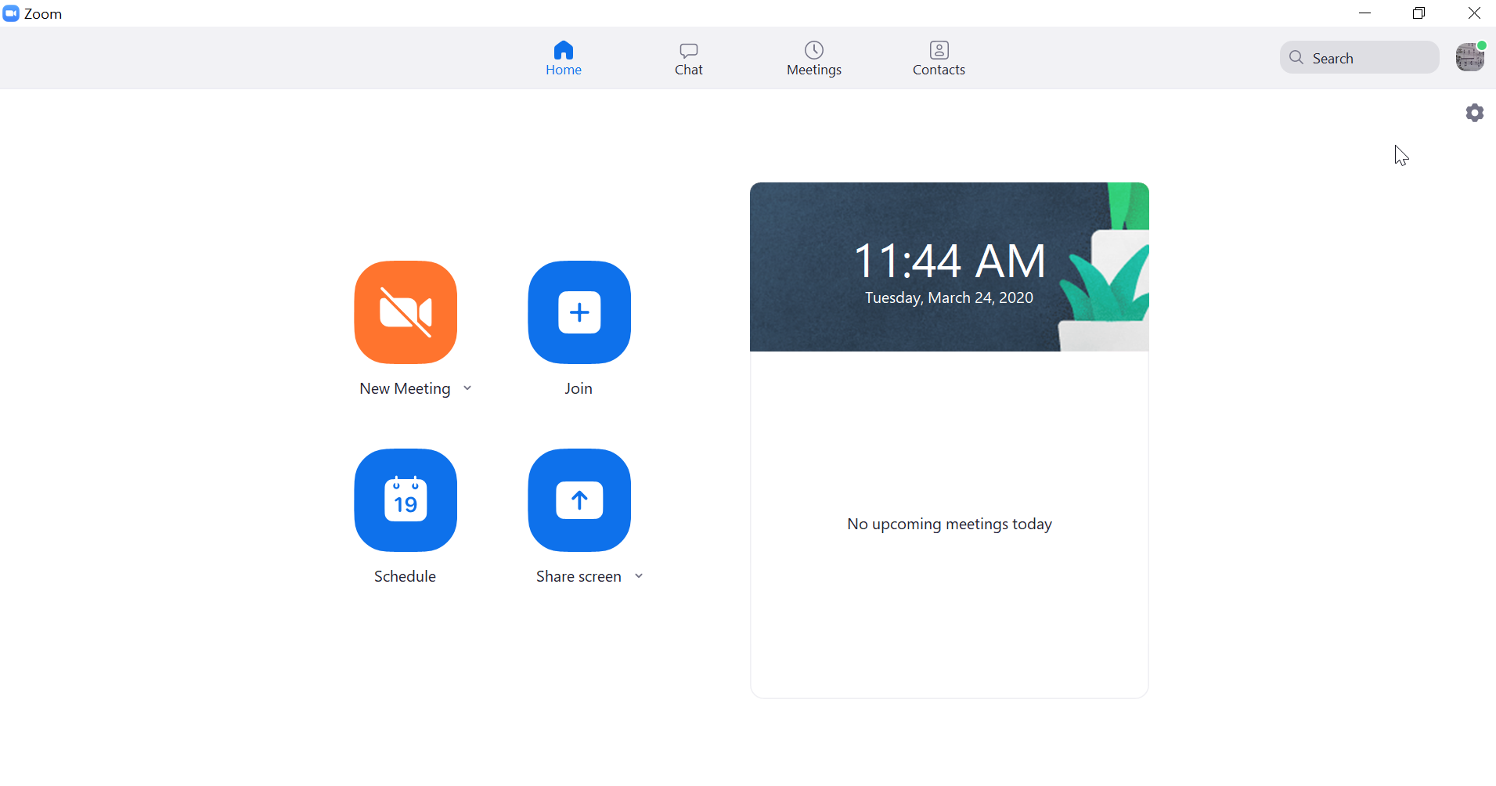
- When you are in a videoconference, look at the top left hand corner of the screen and make sure it says “Turn Off Original Sound”. If it says “Turn On Original Sound”, click on it so that it changes to “Turn Off Original Sound”. Be sure to look at this in every videoconference.

