Hardware, Connectivity, Positioning

- Hardware choices (any of these will work, but a laptop is preferred because of its flexibility and portability):
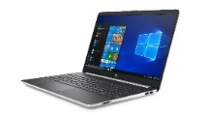
Laptop computer

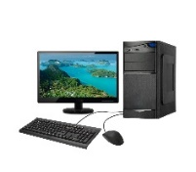
Desktop computer (with built-in or added camera and microphone)

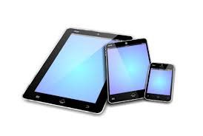
Mobile device (iPad, IPhone, Android, etc.)

- Connectivity: Most of us have internet service at home through Comcast, AT&T, or some other provider. You can purchase greater bandwidth (AKA speed of connection) from your provider. This will likely improve the performance of your videoconferencing, but not necessarily.

If possible, use an Ethernet Cable to connect directly from your computer to your Modem or Router (you cannot do this with mobile devices). The speed of your internet connection is more consistent when you use an Ethernet Cable, as opposed to Wi-Fi (a wireless connection). Be sure you purchase a cable long enough to reach from your Router to your piano. That may be quite long. If your piano is on a different floor than your router, the long length of the cable may be impractical.

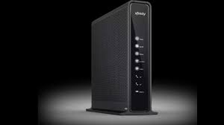
Modem – is the device that almost everyone has that connects you directly to the internet. You can plug in your devices directly to a modem, though it is more likely that you have a router for that.

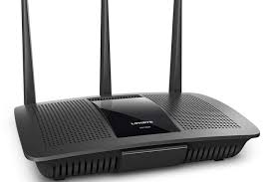
Router – is a device that serves as a hub (place to plug in) for your devices and sends Wi-Fi signals throughout your home. You almost certainly have a router if you have internet service, though it is possible you only have a modem.

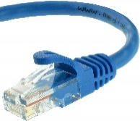
Ethernet Cable – is a special cable (a little larger than a telephone cable). Generally, you will want to get a cable that is rated CAT-5 or CAT-6. These are very common items that come in various lengths and are easily findable on Amazon and other sellers.

- Placement of your device - Place your desktop or mobile device approximately 4-5 feet from your piano. I have found this improves the quality of the sound. Be aware though that you may have to move closer to your device when you are talking.

