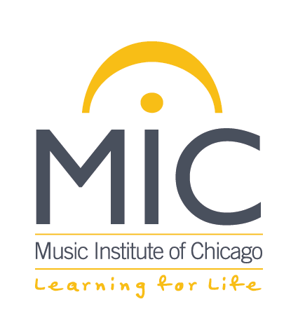

PUBLICITY CONSENT

Photographs, audio, and video of students engaged in Music Institute of Chicago activities including but not limited to instruction, rehearsal, workshop or performances may be used in the Music Institute’s publications, newspapers, magazines, radio, and other related publicity materials including the internet. Your signature on this waiver/release form constitutes consent and permission by the student and students’ parent(s) and/or legal guardians to use the student’s name and/or image/audio for any advertising, publicity, marketing, or packaging. This release is irrevocable.

Signature of Parent

Name of Student (please print)

Date

